RESOLUTION NO.__________

RE: CERTIFICATE OF APPROPRIATENESS UNDER THE
PROVISIONS OF THE ACT OF THE PENNSYLVANIA
LEGISLATURE 1961, JUNE 13, P.L. 282 (53
SECTION 8004) AND BETHLEHEM ORDINANCE NO.
3952 AS AMENDED.

The applicant proposes to install a 12” x 30 ½” wood panel sign at 79 W. Market St.

NOW, THEREFORE, BE IT RESOLVED by the Council of the City of Bethlehem that a Certificate of Appropriateness is hereby granted for the proposal.

Sponsored by: (s)

(s)

ADOPTED BY COUNCIL THIS DAY OF

(s)
President of Council

ATTEST:

(s)
City Clerk

HISTORICAL & ARCHITECTURAL REVIEW BOARD

The applicant proposes to install a 12” x 30 ½” wood panel
sign at 79 W. Market St.

APPLICATION #6:

Rudy Amelio
79 W. Market St.
Bethlehem, PA 18018

OWNER:

__________________________________________________________________________

The Board upon motion by Beth Starbuck and seconded by Gen Marcon adopted the proposal that City Council issue a Certificate of Appropriateness for the following:

- The new sign is to have a light ivory background.

2. There is to be a black pin striping approximately ½” from the edge in lieu of border.

3. The motion was unanimously approved.

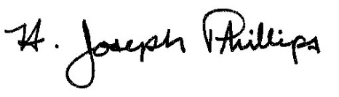 By:__H. Joseph Phillips___________

Title: __Historic Officer____________

Date of Meeting: November 7, 2018

